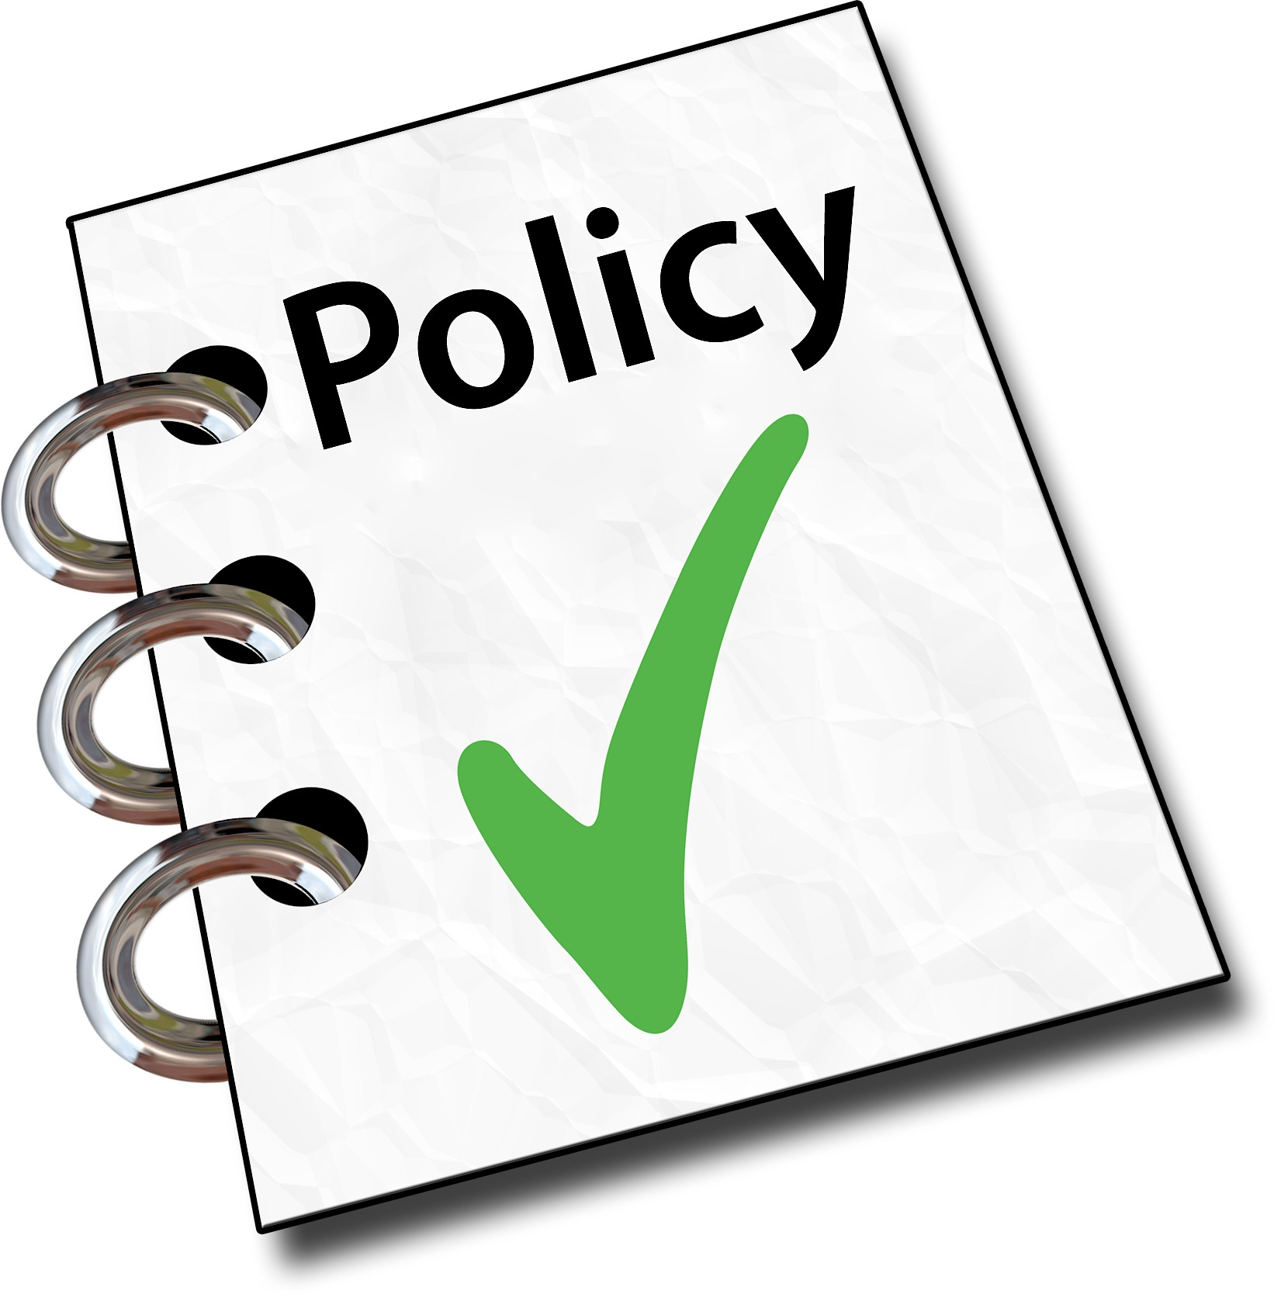

POLICY # 8500 FOOD SERVICES

The Board of Education shall provide cafeteria facilities in all school buildings where space permits, and will provide food service for the purchase and consumption of lunch for all students.

The food service program shall comply with Federal and State regulations pertaining to the selection, preparation, delivery, consumption, and disposal of food and beverages as well as to the fiscal management of the program as well as all Federal and State requirements pertaining to food service hiring and food service manager/operator licensure and certification. In addition, as required by law, a food safety program based on the principles of the Hazard Analysis and Critical Control Point (HACCP) system shall be implemented with the intent of preventing food-borne illnesses. For added safety and security, access to the facility and the food stored and prepared therein shall be limited to food service staff and other authorized persons.

Substitutions to the standard meal requirements shall be made, at no additional charge, for students for whom a health care provider who has prescriptive authority in the State of Wisconsin has provided medical certification that the student’s medical condition restricts his/her diet, in accordance with the criteria set forth in 7 C.F.R. Part 15b. To quality for such substitutions the medical certification must identify:

A. the student’s medical condition or symptoms of a condition that restricts one (1) or more major life activity or function;

B. an explanation of how the condition or symptom affects the student’s diet; and

C. the food(s) to be omitted from the student’s diet, and the food or choice of foods that must be substituted (e.g. caloric modifications or use of liquid nutritive formula).

On a case by case basis, substitutions to the standard meal requirements may be made, at no additional charge, for students who provide a signed statement from a qualified medical authority that the student cannot consume certain food items due to medical or other special dietary needs, but which does not comply with the requirements above. To qualify for such consideration and substitutions the medical statement must identify:

A. the medical or dietary need that restricts the student’s diet; and

B. the food(s) to be omitted from the student’s diet and the food(s) or choice of foods that may be substituted.

The District may provide a student with a substitute meal without any certification provided that the meal still meets the USDA meal pattern for reimbursement.

For students who need nutritional equivalent milk substitute, only a signed request by a parent is required.

Lunches sold by the school may be purchased by students and staff members and community residents in accordance with the rules of the District’s school lunch program.

The operation and supervision of the food service program shall be the responsibility of the Food Service Director and the Business Manager. Food services shall be operated on a self-supporting basis with revenue from students, staff, Federal reimbursement, and surplus food. The Board shall assist the program by furnishing available space, initial major equipment, and utensils. Maintenance and replacement of equipment is the responsibility of the program.

A periodic review of the food service accounts shall be made by the Business Manager. Any surplus funds from the National School Lunch Program shall be used to reduce the cost of the service to students or to purchase cafeteria equipment. Surplus funds from a-la-carte foods purchased using funds from the nonprofit food service account must accrue to the nonprofit food service account.

The food service program may participate in the “Farm to School Program” using locally grown food in school meals and snacks.

Bad debt incurred through the inability to collect lunch payment from students is not an allowable cost chargeable to any Federal program. Any related collection cost, including legal cost, arising from such bad debt after they have been determined to be uncollectable are also unallowable. District efforts to collect bad debt shall be in accordance with Policy 6152 – Student Fees, Fines, and Charges.

Bad debt is uncollectable/delinquent debt that has been determined to be uncollectable by the end of the school year in which the debt was incurred. If the uncollectable/delinquent debt cannot be recovered by the School Meals Program in the year when the debt was incurred, then this is classified as bad debt. Once classified as bad debt, non-Federal funding sources must reimburse the NSFSA for the total amount of the bad debt. The funds may come from the District general fund, State or local funding, school or community organizations such as the PTA, or any other non-federal source. Once the uncollectable/delinquent debt charges are converted to bad debt, records relating to those charges must be maintained in accordance with the record retention requirements in 7 CFR 210.9(b)(17) and 7 CFR 210.15(b).
Students will be permitted to purchase meals from the District’s food service using either cash on hand or a food service account. A student may be allowed to incur a negative food service account balance subject to the following conditions.

Students may be permitted to accumulate negative food service account balance as determined by the District Administrator. The District Administrator shall determine the manner of determining permissible account balances by grade level. A student shall not be permitted to purchase a la carte items without sufficient account balance or cash on hand. Likewise, any student that has a negative account balance may not purchase a la carte items with cash unless the student is also able to bring his/her account current.

This policy and any implementing guidelines shall be provided in writing to all households at the start of each school year and to households transferring to the school or School District during the school year. The policy and implementing guidelines will also be provided to all District staff with responsibility for enforcing the policies. The policy and guidelines will be posted to the District website.

No foods or beverages, other than those associated with the District’s food service program, are to be sold during food service hours.

The District’s food service program shall serve only food items and beverages determined by the Food Service Department to be in compliance with the current USDA Nutrition Standards for the National School Lunch and School Breakfast Programs. Any competitive food items and beverages that are available for sale to students a la carte in the dining area between midnight and thirty (30) minutes following the end of the school day shall also comply with the current USDA Nutrition Standards for the National School Lunch and School Breakfast Programs and the USDA Smart Snacks in School nutrition guidelines. Foods and beverages unassociated with the food service program may be vended in accordance with the rules and regulations set forth in Board Policy 8540.

The District Administrator will require that the food service program serve foods in the schools of the District that are wholesome and nutritious and reinforce the concepts taught in the classroom.

The District Administrator is responsible for implementing the food service program in accordance with the adopted nutrition standards and shall provide a report regarding the District’s compliance with the standards at one of its regular meetings annually.

Nondiscrimination Statement

The following statement applies to all programs administered by the District that are funded in whole or in part by the U.S. Department of Agriculture (USDA):

In accordance with Federal civil rights law and U.S. Department of Agriculture (USDA) civil rights regulations and policies, the USDA, its Agencies, offices, and employees, and institutions participating in or administering USDA programs are prohibited from discriminating based on race, color, national origin, sex, disability, age, or reprisal or retaliation for prior civil rights activity in any program or activity conducted or funded by USDA.
Persons with disabilities who require alternative means of communication for program information (e.g. Braille, large print, audiotape, American Sign Language, etc.) should contact the Agency (State or local) where they applied for benefits. Individuals who are deaf, hard of hearing or have speech disabilities may contact USDA through the Federal Relay Service at (800)877-8339. Additionally, program information may be made available in languages other than English.

To file a program complaint of discrimination, complete the USDA Program Discrimination Complaint Form, (AD-3027) found online at : http://www.ascr.usda.gov/complaint_filing_cust.html, and at any USDA office, or write a letter addressed to USDA and provide in the letter all of the information requested in the form. To request a copy of the complaint form, call (866)632-9992. Submit your completed form or letter to USDA by:
Mail:
U.S. Department of Agriculture
Office of the Assistant Secretary for Civil Rights
1400 Independence Avenue, SW
Washington, D.C. 20250-9410;

Fax: (202) 690-7442; or

E-mail: program.intake@usda.gov.

This District is an equal opportunity provider.

Legal References
SP 32-2015 Statements Supporting Accommodations for Children with Disabilities in the Child Nutrition Programs
OMB Circular No. A-87 USDA Smart Snacks in School Food Guidelines (effective July 1, 2014)
Child Nutrition Act of 1966, 42 U.S.C. 1771 et seq.
Healthy, Hunger-Free Kids Act of 2010 and Richard B. Russell National School Lunch Act, 42 U.S.C. 1751 et seq.
42 U.S.C. 1758
15.137, 93.49, 115.34-115.345, 120.10(16), 120.13(10), Wis. Stats.
7 C.F.R. Parts 15b, 210, 215, 220, 225, 226, 227, 235, 240, 245, 3015
42 U.S.C., Chapter 13

