Hilbert Elementary School
4K School Supply List
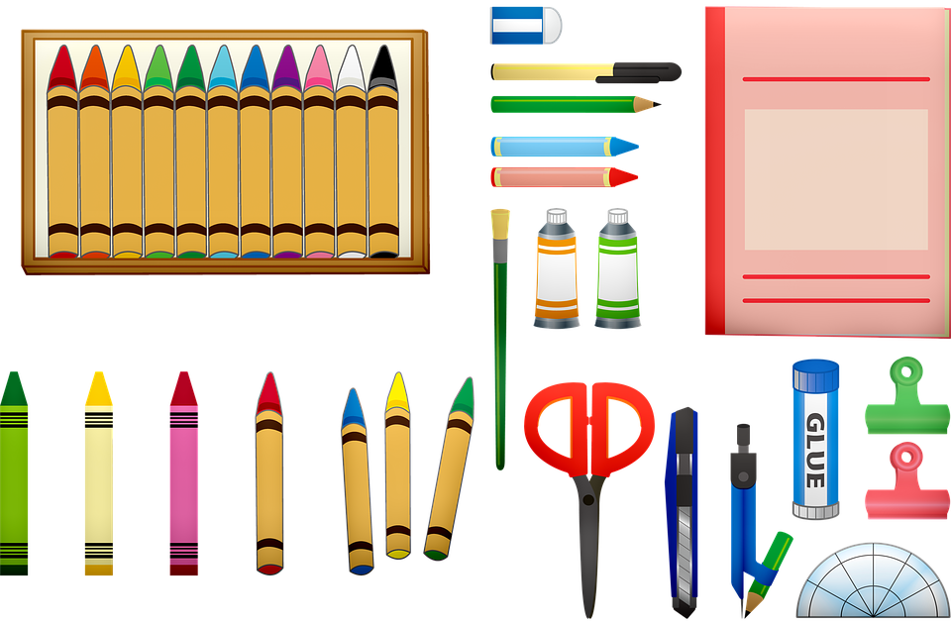

- 1 - backpack
- 1 - folder (labeled)
- 1 - box of crayons
- 2 - boxes of markers
- 1 - pack of glue sticks
- 1- bottle of glue
- 1 - composition notebook
- 1 - pack of dot stickers (any color, just plain circles)
- 1 - pack of fun stickers
- 4 - containers of Playdough
- 1- zipper pencil pouch
- 1- pack of napkins

- 1 - set of extra clothes in a gallon bag labeled (shirt, pants, socks and underwear)
- 1 - container of disinfectant wipes
- 1- set of watercolor paints
- 1 - printed photo of your family to hang in our classroom
- 2 - boxes of snack items (individually packaged)
- 1- small blanket for rest time (should fit in a shoe box)

If you have questions or concerns, please contact Mrs. Davis or Mrs. Beth Ott prior to the open house (davisb@hilbertk12.org/otte@hilbertk12.org).

Please bring all supplies to the Open House on Thursday,
August 31st from 4-6PM so they can get arranged before the first day.

23/24

