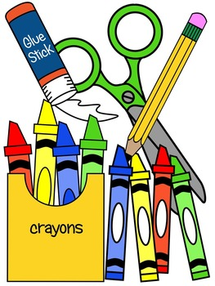

HILBERT ELEMENTARY SCHOOL

Dear Parents:

The following is a list of items your child will need in the fall for
K I N D E R G A R T E N:

- Backpack
- Tennis shoes (unless being worn to school)
- Paint shirt (an old shirt of Mom or Dad’s is fine)
- STURDY plastic pencil case (smaller size) – No bags please
- 4 LARGE glue sticks
- 1 child-size Fiskars scissors
- 1 composition book
- 3 2-pocket folders - to be used as take home folders
- 1 2-pocket folder (no prongs please) - Blue
- 1 16 or 24-count box of small crayons
- 2 sets of Crayola washable markers (8 or 12 count) NO SKINNY MARKERS, PLEASE
- 2 packs of 4 Expo fine point dry erase markers
- 1 set of over-the-ear headphones
- 2 boxes of Kleenex
- 2 containers of Clorox wipes
- Extra set of clothes (Please label and put them in a Ziploc bag.)
- One large box or bag of a snack to share (Ex. box of crackers)
- Reusable water bottle
- Plastic container with lid (size 15 Quart)

If you would like to send for our classroom:
✔1 box reclosable Snack or Gallon (Ziploc) plastic bags
✔3 Large glue sticks
✔1 package of plain, white, inexpensive paper plates (big & small)
✔1 big roll of white paper towel

MARK YOUR CALENDAR
Open House: Thursday, Aug. 31, 2023 4-6PM
First Day of School: Sept. 5th

2023/24

